**PM3 Submission**

**Team: Red Cats**

1. What are the top 5 most affordable (in terms of price per square foot), safest (in terms of number of crime report), and youngest (in terms of median age) areas by zip code with weight of 50% towards rental price, 30% towards crime counts, and 20% towards median age?

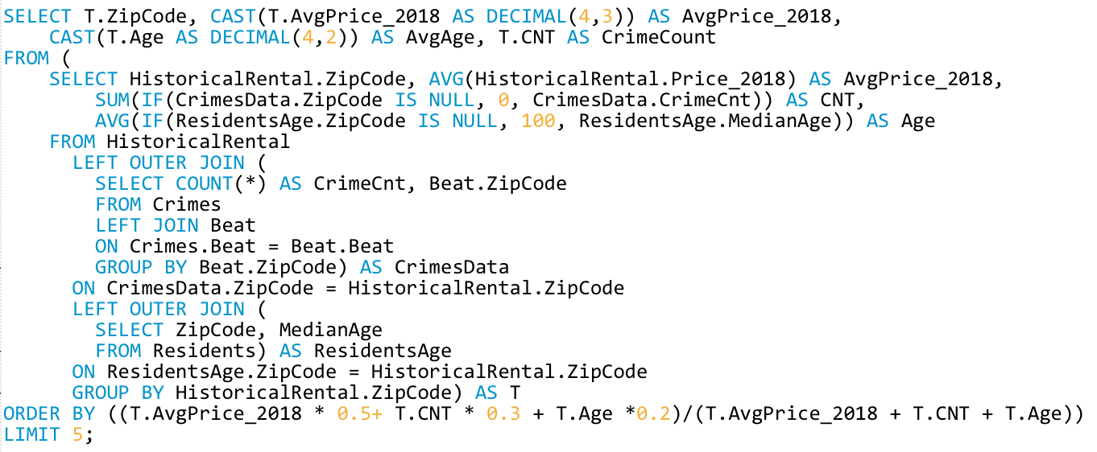

Result:

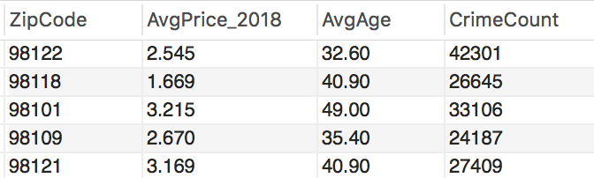

1. What is the most affordable rental neighborhood in 2018 YTD with average price per square foot:

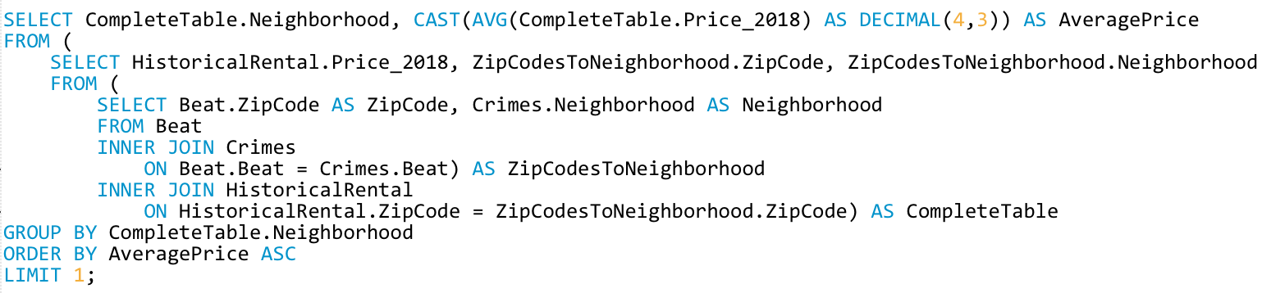

Result:

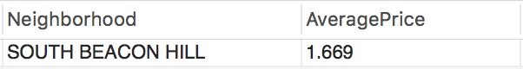

1. Rank crime category by number of reports in each neighborhood.

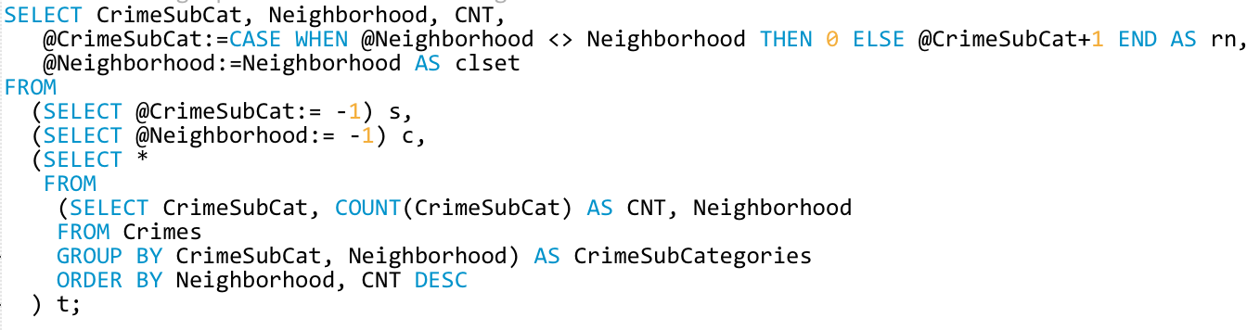

Result:

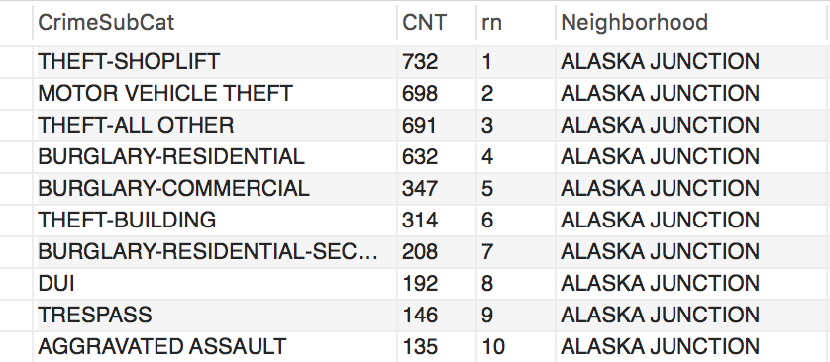

1. What are the top five safe areas in terms of number of crime reports with low rental price by zip code?

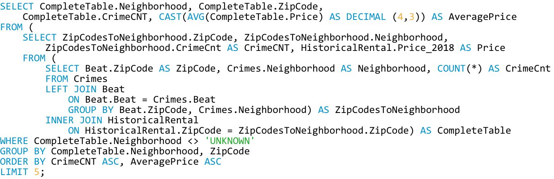

Result:

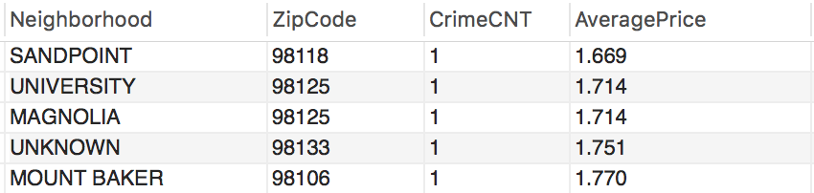

1. What are the top five affordable area in terms of median rental price per square foot in 2017?

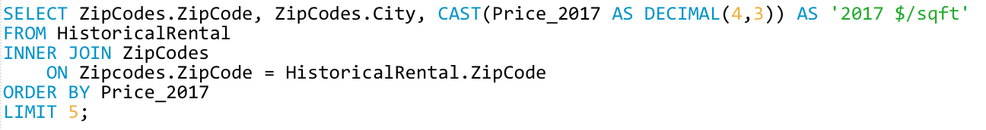

Result:

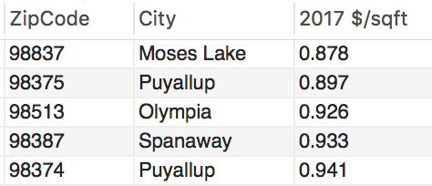

1. Which zip codes have the rental price in the range of $2/sqft – $2.5/sqft in 2018?

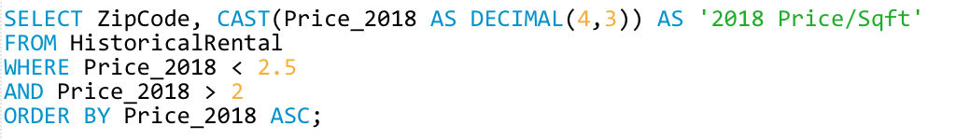

Result:

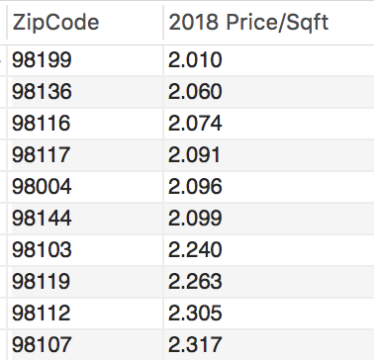

1. Which are the top 5 area (zip code) that have the cheapest median rental price in terms of price / sqft in 2018 ordered by number of car crisis in ascending order?

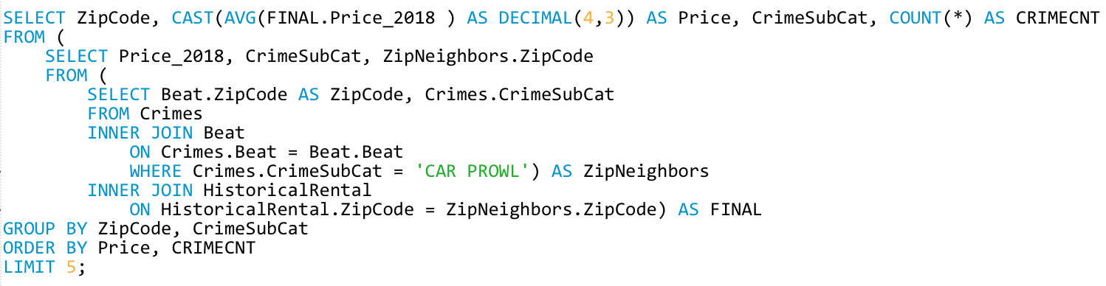

Result:

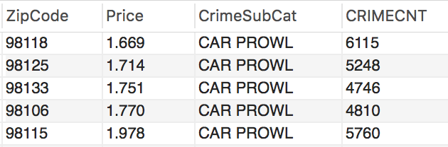

1. What is the estimated rental price per square foot for the area with zip code 98004?

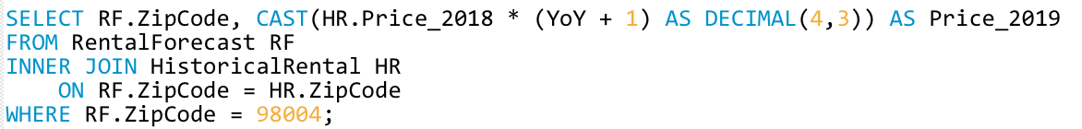

Result:

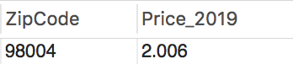

9. What is the youngest community in Seattle Metro area by zip code with the name of the city and median age?

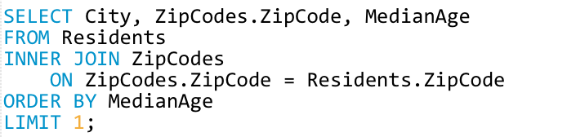

Result:

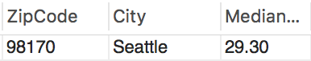

10.What is sagest neighborhood in terms of number of crimes to live in?

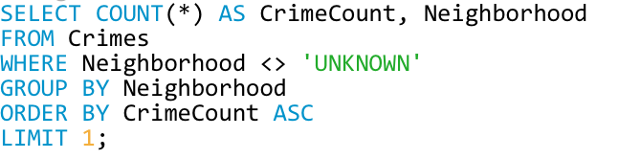

Result:

